Patient Information Form

Name – First: Last: M.I.:
Nickname: Date of Birth: Gender: M / F

Mailing Address: City: State: Zip:
Physical Address: City: State: Zip:
Home Phone: Cell Number:
Email:

Parent/Guardian/Spouse (Primary Insurance Holder)
Name – First: Last: M.I.:
Date of Birth: Gender: M / F SSN (military):
Mailing Address: City: State: Zip:
Physical Address: City: State: Zip:
Home Phone: Cell Number:
email:

Primary Medical Insurance
Insurance Company: ID#:
Policy Holder: Group #:

Secondary Medical Insurance
Insurance Company: ID#:
Policy Holder: Group #:

Referral Source (Who may we thank?):

Primary Care Physician: (Name and Clinic)
Date last seen by PCP:

Do you see any other providers? If so, who and what type of specialty?

Billing Policies

Agreement to Pay for Treatment:

I hereby agree to pay all charges submitted by this office during the course of treatment for the patient. If the patient has insurance coverage with a managed care organization with which this office has a contractual agreement, I agree to pay all applicable co-payments, co-insurance and deductibles, which arise during the course of treatment for the patient. I further agree to pay for treatment rendered to the patient which is not considered to be a covered service by my insurer. A third-party insurer or other payer.
I understand that not paying for treatment will lead to my account being sent to collections and being dismissed from AFAC.

Financial Responsibilities:

I understand that it is my responsibility to:
- provide AFAC with correct insurance information for billing purposes
- contact my insurance company to verify my benefits
- respond to all requests for information I may receive from my insurance company
- pay all co-payment or co-insurance amounts at time of service
- pay all balances not paid by my insurance company, immediately upon receipt of a bill from AFAC

Payment for DME:

I understand that splinting, orthotics and other durable medical equipment (DME) that the patient may receive during the course of treatment may not be a covered benefit under my insurance plan. I understand that supply costs not covered by my insurance are my responsibility and I agree to pay for these supplies.
I understand that if orthotics are ordered for the patient, I will be responsible for $100.00 deposit that may be refunded to me once my insurance pays for the orthotic.
I understand it is my responsibility to contact my insurance regarding coverage for Orthotics/DME.
I understand the fee for custom fit orthotics is $550.00 which is non-returnable and non-refundable once an order is placed.

Assignment of Benefits:

I hereby assign all benefits, in include major medical benefits, to which I am entitled. I hereby authorize and direct my insurance carrier(s), including Medicare, private insurance, auto, or any other health/medical plan, to issue payment check(s) directly to AFAC for medical services or supplies rendered to myself or my dependents regardless of my insurance benefits, if any. This assignment will remain in effect until revoked by me in writing. I understand that I am responsible for any amount not covered by my insurance.

Patient Name: Date of Birth:

Patient Signature Date

Responsible Party Signature Date

Billing Notices

No Show:

I understand that if I fail to cancel my office visit appointment without 24 hours prior notice, I will be charged $50.00 for the first appointment and $75.00 for each appointment after.

I understand that if I fail to cancel my surgery or office procedure without 24 hours prior notice, I will be charged $200.00 for the missed appointment.

I understand that if I No Show for three appointments I will be dismissed from AFAC.

Additional Fees:

$50.00 – Service fee if account is sent to collections
$25.00 – Service fee for NSF check returns from your bank
$25.00 – Administrative fee for completion of forms, including FMLA, Disability, or other job-related
$5.00 – Copy fee for x-rays

Medicare:

I understand that if I have Medicare that AFAC bills Medicare for me and I do not need to submit a claim myself. I understand that Medicare pays 80% of the allowable amount after I have met my deductible. It is my responsibility to pay for the remaining amount.
If I have Medicare supplemental insurance, it is my responsibility to provide this information to AFAC prior to receiving treatment.

I understand that Medicare does not pay for Orthotics and that I will need to meet specific Medicare requirements to have my foot/nail care covered. If covered, these services will only be paid by Medicare every 61 days. I understand that it my responsibility to pay for services not covered by Medicare. An Advanced Beneficiary Notice will be supplied to me when appropriate to help me make an informed decision about payment of my medical care.

Payment at Time of Service:

I understand that AFAC expects payment at time of service for all co-payments, co-insurance, or non-covered services.
AFAC accepts cash, personal checks, Mastercard and Visa

Patient Name: Date of Birth:

Patient Signature Date

Responsible Party Signature Date

Authorizations to Release Information

I hereby authorize AFAC to release protected health information (PHI) necessary to assist in the reimbursement of benefits of which I may be entitled.
I hereby authorize AFAC to request/release PHI necessary to assist in my medical treatment (including other medical providers I see, hospitals, facilities, etc.)

I hereby authorize AFAC to disclose my health information to:
Relationship:
This authorization is effective from the date of signature until , or until I revoke this authorization, whichever is soonest.

I hereby authorize AFAC to disclose my health information to:
Relationship:
This authorization is effective from the date of signature until , or until I revoke this authorization, whichever is soonest.

I hereby authorize AFAC to disclose ONLY my Billing information to:
Relationship:
This authorization is effective from the date of signature until , or until I revoke this authorization, whichever is soonest.

Patient Signature Date

I hereby authorize AFAC to (initial each item being authorized)

Leave a detailed message on my Cell Phone:
Leave a detailed message on my Home Phone:
Leave a detailed message on my Work Phone:
Send me detailed appointment reminder information to my Cell (Text)
Send detailed information regarding my health and/or appointments to my
Email:
Send detailed information to me via Mail
Download my medication history and prescription benefits into my clinic account

The AFAC Notice of Privacy Practices is available for your review on our website or in the binder in our lobby. The Notice provides a detailed description of what we do with your protected health information. It also explains your rights for getting access to that information and controlling its use and disclosure.

I understand that I have been offered a copy of AFAC’s Notice of Privacy Practices.

Patient/Responsible Party Signature Date

Patient Name: Date of Birth:
Height: Weight:
Shoe Size: Width: Do you wear Orthotics? Yes / No
Preferred Pharmacy:
Primary Care Physician:

Medical History: List any major medical conditions including those for which you take medication

If you have Diabetes: Recent Hemoglobin A1c _________ Recent blood sugar: ___________

Current Medications: List Name and Dosage Allergies: List allergen and reaction

Past Surgical History: Within past 10 years- List surgeries & approximate year

Do you smoke cigarettes or vape? Yes / No If yes, current # of packs per day?

Do you drink alcohol? Yes / No If yes, number of drinks per week?

Do you use recreational drugs? Yes / No If yes, which?

Hospitalization History:

Have you ever had post-operative infection? Yes / No

Have you had poor wound healing? Yes / No

Do you have a pain contract with a pain management provider? Yes / No
If so, who is your provider?

What is the primary reason for evaluation today?

Have you had previous imaging regarding this issue? (X-rays, MRI, etc.) When/Where?

Do you have any of the following symptoms currently or have you within the last 6 months? (Indicate Right/Left/Both)
Foot/Ankle Pain Heel Pain
Foot/Leg Cramps Swelling in Foot/Ankle
Bunions Corns/Calluses Tired Feet Numbness in Foot
Flat Feet High Arch
Ingrown Nails Fungal Nails
Leg/Foot Ulcers Broken Foot/toe

Do you get leg cramps after activity? Yes / No
Does foot pain limit your desired activities? Yes / No
Do you have difficulty walking or are you limping? Yes / No
What sports/activities are you involved in:

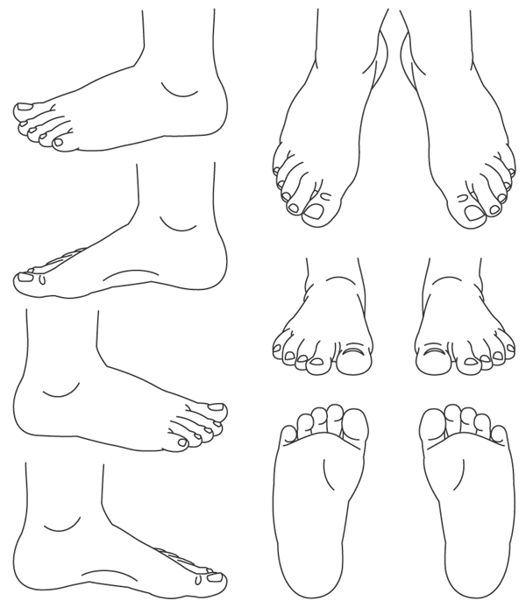

Indicate the location of your problem or pain on this diagram:

Does the pain radiate to elsewhere on your foot/leg? Please describe:

